SUMMARY

This report was prepared within the LIFE Integrated Project “Optimising the Governance and Management of the Natura 2000 Protected Areas Network in Latvia” LIFE19 IPE/LV/000010, Action A.4. The action aims at improving the site management planning system in Latvia by critically evaluating the current system including assessment of the legal basis and feasibility of the changes.
This report analyses the views of the various stakeholders on the current procedure of the protected nature areas management plan development and on the possible improvements in this planning system. The opinions were gathered by interviews, consultative group meetings, other meetings, workshops and via focus group discussion. Two questionnaires were prepared and sent out: for those involved in the development of the site management plans and for the local municipalities. Assessment of the legal basis and feasibility of the changes was done by the law firm “fairLEX”. In cooperation with Action C.9 the analysis of Nature Data Management System OZOLS was carried out. In cooperation with Action E.2.1 the overview on site management planning and implementation in other EU member states was carried out. All aforementioned information was analysed and summarized in this report.
The final report is structured in several thematic blocks: the aim and the tasks of the site management plan, the content of the plan, public engagement, the legal status of the site management plan and the implementation of the plan. Each of the blocks summarises both the problems identified and points to their possible solutions. A summary of the proposed solutions is provided, assessing their compliance with the project objectives. In conclusion, recommendations for a new framework of the management plans are provided.
This report will serve as the basis for the development and testing of a new framework for the improvement of site management planning in Activity C.2.
Partners involved in the Action A.4.: Ministry of Environmental Protection and Regional Development, Nature Conservation Agency, Vidzeme University of Applied Sciences.
The Project “Optimising the Governance and Management of the Natura 2000 Protected Areas Network in Latvia” (LIFE19 IPE/LV/000010 LIFE-IP LatViaNature) is implemented with the financial support of the LIFE Programme of the European Union and Latvian State Regional Development Agency.
The information reflects only the LIFE-IP LatViaNature project beneficiaries’ view and the European Commission’s Executive Agency for Small and Medium-sized Enterprises is not responsible for any use that may be made of the information contained therein.
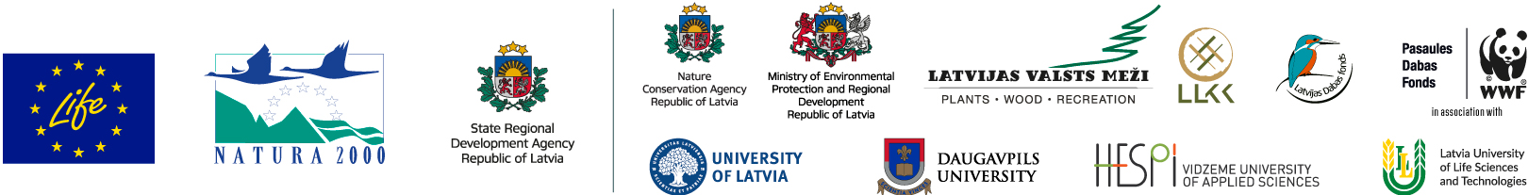
The Project “Optimising the Governance and Management of the Natura 2000 Protected Areas Network in Latvia” (LIFE19 IPE/LV/000010 LIFE-IP LatViaNature) is implemented with the financial support of the LIFE Programme of the European Union and Latvian State Regional Development Agency.
The information reflects only the LIFE-IP LatViaNature project beneficiaries’ view and the European Commission’s Executive Agency for Small and Medium-sized Enterprises is not responsible for any use that may be made of the information contained therein.

