SUMMARY

Sub-Action C.5.1: Adjusting National biodiversity monitoring system to detect invasive alien species (IAS).

The aim of the activity is to revision and adapt 11 methodologies of the National Biodiversity Monitoring Programme (NBMP) subprogrammes to include data collection on IAS.
To reach the aim of the activity, in its 1st stage, an expert working group (nine experts) developed criteria for the selection of alien plant and animal species. Based on these criteria, the experts identified the species that show or may show features of invasion in Latvia and these species were divided in the black, grey and observation lists. In total 74 plant species and 84 animal species were evaluated. As Latvia is legally bound to implement Council of Europe Regulation 1143/2014, an extended assessment was carried out for all species (in total 40 plant species and 47 animal species) included in the annexes to this Regulation. Based on the obtained results, it was concluded that 62 plant species (seven of these are included in the annexes of Council of Europe Regulation 1143/2014) and 33 animal species (12 of these are included in the annexes of Council of Europe Regulation 1143/2014) need to be included in the relevant NBMP subprogramme.
In the 2nd stage of the activity, the experts developed an evaluation form for the methodologies of the NBMP subprogrammes. This ensured that all experts involved used the same evaluation approach. Using this form, the experts evaluated the methodologies of 16 NBMP subprogrammes. It was concluded that 12 of these methodologies could be adapted to provide data on relevant IAS. Also, all methodologies adapted to the subprogrammes incorporate early detection steps for IAS, which is a very important step in the effective management of IAS.
The Project “Optimising the Governance and Management of the Natura 2000 Protected Areas Network in Latvia” (LIFE19 IPE/LV/000010 LIFE-IP LatViaNature) is implemented with the financial support of the LIFE Programme of the European Union and Latvian State Regional Development Agency.
The information reflects only the LIFE-IP LatViaNature project beneficiaries’ view and the European Commission’s Executive Agency for Small and Medium-sized Enterprises is not responsible for any use that may be made of the information contained therein.
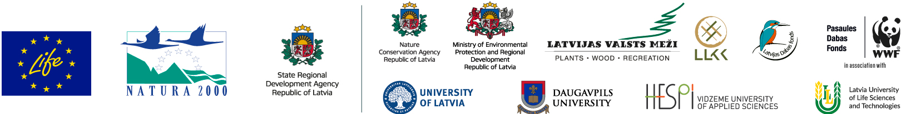
The Project “Optimising the Governance and Management of the Natura 2000 Protected Areas Network in Latvia” (LIFE19 IPE/LV/000010 LIFE-IP LatViaNature) is implemented with the financial support of the LIFE Programme of the European Union and Latvian State Regional Development Agency.
The information reflects only the LIFE-IP LatViaNature project beneficiaries’ view and the European Commission’s Executive Agency for Small and Medium-sized Enterprises is not responsible for any use that may be made of the information contained therein.

